Use-Case Realization Report
UpdateFap

Issue <1.0>
Revision History
Date | Issue | Description | Author
<02/08/09> | <1.0> | <UpdateFAP> | <Karen Gao>

Table of Contents
1. Brief Description 4
2. Flow of Events 4
3. Interaction Diagrams 4
3.1 Collaboration Diagram for UpdateFap 4
4. Participating Objects 4
5. Class Diagrams 5
5.1 Class Diagram for UpdateFap 5
6. Derived Requirements 5

Use-Case Realization Report
UpdateFap

Brief Description
The update of FAP shall be executed once the selection check for the existing FAP list was performed.

Flow of Events

Standard Flow
This use case covers the events of updating FAP, which is part of the Maintenance FAP package. The standard flow of events is described as below:
- The Portal Administrator shall press the button to send out a command of “updateButtonClicked” on the interface of MaintainFapPage.
- Once MaintainFapController received this request, the operation checkFapToUpdate will check if there’s Fap seleted.
- Then the operation getFunctionDataList will get the Function List from object of ModuleData, and show to the MaintainFapPage through the operation showFunctionDataList.
- The operation selectFunctionData will select the Functions for the Fap
- Then the operation updateFapList of the MaintainFapController will update the new list of Fap object
- Once it’s done, the successful updating Fap will show to the MaintainFapPage.

Exceptions

- If there’s no selection found in Fap records, a warning message will be show to the MaintainFapPage through the operation showNoFapSelectedMsg.

Interaction Diagrams

Collaboration Diagram for UpdateFap
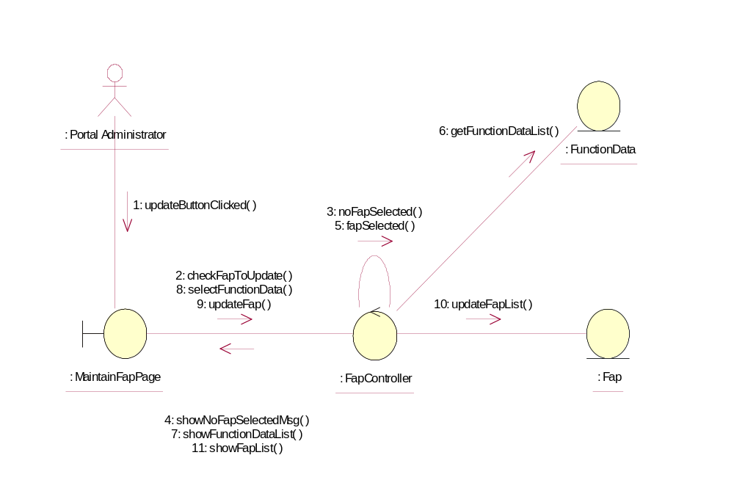

Participating Objects
: Fap
This Entity is Fap object

: FapController
This controller is to add, delete and update Fap

: FunctionData
This Entity is FunctionData object

: MaintainFapPage
This is a page for adding, deleting, updating and displaying Fap

: Portal Administrator
This is the super user of the system.

Class Diagrams

Class Diagram for UpdateFap
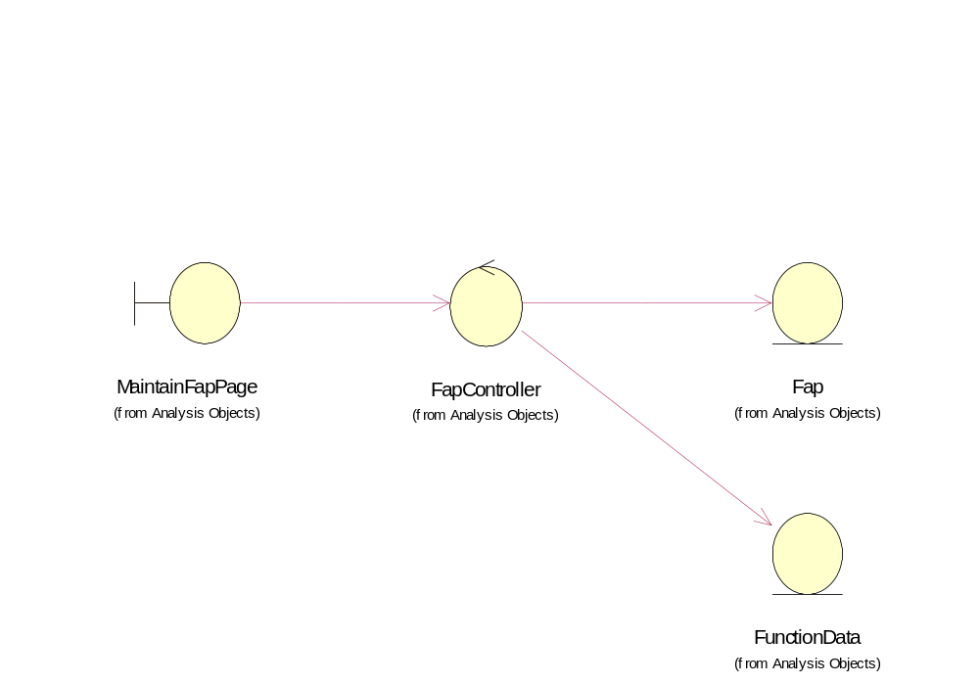

Derived Requirements
Only Portal Administrator has rights to access this page.

